INSPECTORATUL ȘCOLAR JUDEȚEAN
DÂMBOVIȚA
VARIANTA NR. 1

I. Read this email from Tess, an English-speaking girl travelling round South America with her friend Helen. Decide whether statements 1-6 are true or false. Write T or F on the line at the end of the statements.

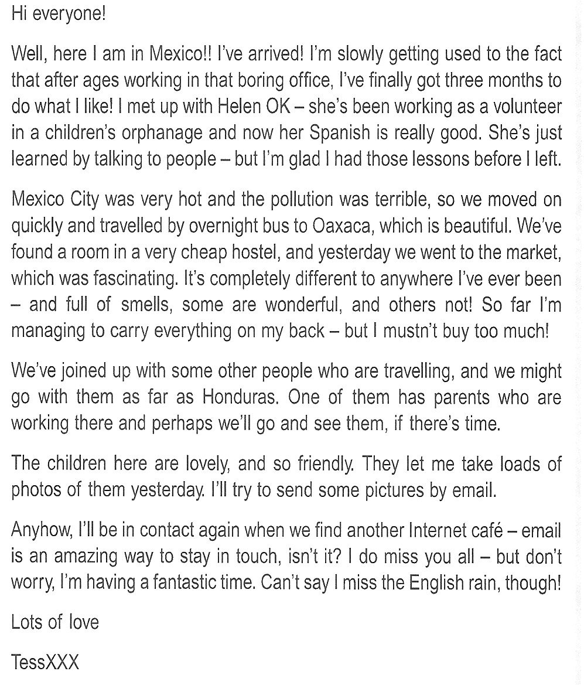

- Helen has been having Spanish classes in Mexico. ____
- Tess and Helen have found somewhere impressive to stay. ____
- Tess’s luggage is too heavy to carry. ____
- They are going to see Helen’s family in Honduras. ____
- Tess has taken lots of photos of children. ____
- Tess doesn’t miss the British weather. ____

(6 items * 2 points = 12 points)

II. Choose the best answer:

1.”What perfume are you wearing?” “It’s called Beautiful. I love the way it … .”
A is smelling B smells C does smell
2.”Have you made plans for Saturday yet?” “Yes, Mary and I … to the cinema.”
A are going B go C am going
3. She has a terrible headache because she … in the sun for hours.
A is walking B walks C has been walking
4. … you his proposal yet?
A Has Tim emailed B Has Tim been emailing C Is Tim emailing
5. The weather this winter is even … than last winter.
A the worst B worst C worse
6. Lynn is … as Laura.
A kinder B as kind C as kindest
7. “How do you like your new house?” “We love it. It has … enormous garden!”
A so B such an C what an
8.”Can you give me … advice on how to remove a virus from my computer?” “Sure, no problem.”
A a piece B an C some
9. Our flight takes off in three hours and you … a single thing yet!
A haven’t packed B don’t pack C aren’t packing
10. While Amanda … the dish, she was checking the recipe so as not to make a mistake.
A has been preparing B has prepared C was preparing
11. … the comedy on channel 5 yesterday?
A Had you watched B Did you watch C Were you watching
12. Linda was nervous because she … on an airplane before.
A wasn’t flying B hadn’t flown C didn’t fly
13. I … to tomorrow’s meeting; I’m ill.
A am not going B don’t go C haven’t gone
14. Little Tommy … five next month.
A will be B has been C is going to be
15. She failed to get into the college she wanted … her poor grades.
A as a result B because of C because
16. My head hurts. I … some aspirin.
A take B took C will take
17. Lions don’t run … cheetahs.
A as fast as B the fastest of C so fast than
18. Lisa was very proud when she … to represent her school in the national chess championship.
A selected B has selected C was selected
19. You … that book for a month! Aren’t you done yet?
A are reading B read C have been reading
20. Paula … to Dean that she felt exhausted.
A said B told C informed
(20 items * 2 points = 40 points)
III. Read the following text and fill in the gaps with the correct alternative:
Claude Monet was an artist who lived in France between 1840 and 1926. He is probably the most 1) …… of all the Impressionist painters and today visitors can see his 2) …… paintings in museums around the world. Monet was most 3) ……in painting nature scenes and his most 4) ……works are now very valuable.

1.A. famed B. famous
2.A. beautiful B. beautifully
3.A. interested B. interesting
4.A. impressed B. impressive
(4 items * 2 points = 8 points)
Toate subiectele sunt obligatorii.
Timp de lucru: 1 oră.
Total: 60 puncte
Se acordă 10 puncte din oficiu.

